Exercises Biol-480 “Neuroscience” – Aging

Solutions (29/09/2025)

General questions
- Name 2 stochastic and 2 non-stochastic theories of biological aging.
Stochastic: wear and tear, free radicals (oxidative stress), cross-linkage, somatic mutation
Non-stochastic: programmed theories as telomere shortening, biological clocks, neuroendocrine theory, immunological theory.
- What is the main difference between stochastic and non-stochastic theories?
Stochastic = random cumulative damage over time
Non-stochastic = programmed processes
- Give one example of biomarker of biological age.
Telomere length, DNA methylation patterns, senescence-associated inflammatory markers (ex: SASP), …
- What is the central idea of the mutation accumulation theory?
There is a selection trade-off between reproduction and longevity because of a finite amount of energy
- Explain the disposable soma theory.
Resources for maintenance and repair are invested during the
reproductive span, but not beyond

Case study 1
Gräff et al. (2013) showed that a dietary regimen of caloric restriction or pharmacological activation of SIRT1 can delay the onset of neurodegeneration in mice. Animal studies suggest that caloric restriction reduces age-related decline and protects against Alzheimer’s pathology.
- Cite 2 examples of aging biomarkers you could possibly study in this case (neurodegeneration) and the theory of aging they illustrate.
ROS (free radical theory), amyloid (cross-linkage theory), phosphorylated histone H2A (sign of DNA damage somatic mutations theory)
- Which experimental technique could you use to detect these biomarkers?
Immunohistochemistry/immunofluorescence, mass spectrometry, western blot
- What behavioral test could you use in mice to assess whether caloric restriction protects memory?
Morris water or Barnes maze for spatial learning and memory, novel object recognition, fear conditioning
- The authors were able to activate SIRT1 and delay the onset of neurodegeneration. How would you do such activation?
With SIRT1-activating compounds. Ex: Resveratrol is a natural activator.
- In this paper, the authors used caloric restriction as anti-aging intervention. What alternative of anti-aging intervention could you also use?
Cellular reprogramming

Case study 2
Fjell et al. (2009) used longitudinal MRI to show that normal aging is associated with cortical thinning and hippocampal volume loss, even in healthy older adults. These structural changes predict memory decline and vulnerability to Alzheimer’s disease.
142 healthy elderly participants (60–91 years of age) were followed with repeated MRI (after 1 and 2 years). Blue-cyan areas indicate cortical reduction, while red-yellow areas indicate expansion.
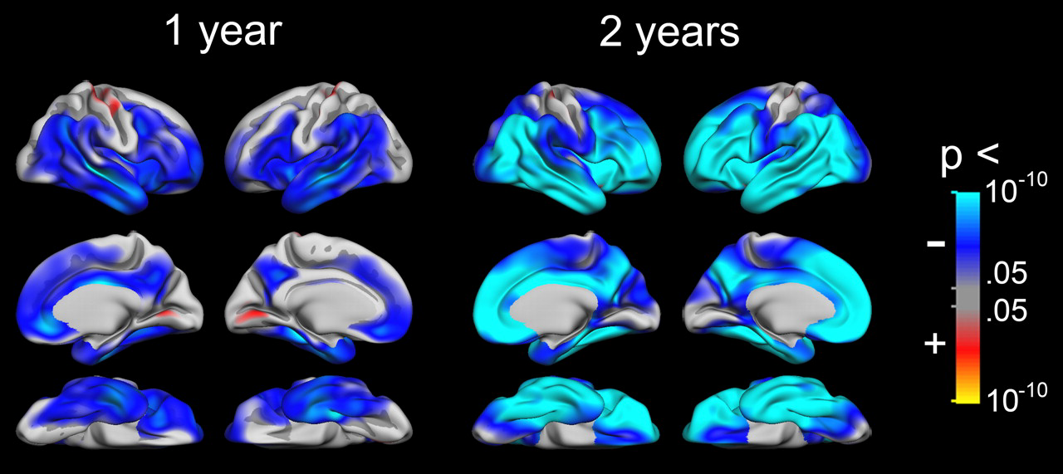
- Which are the brain regions that are the most affected by volume loss?
Frontal and temporal cortices
- Which theory of aging best explains cumulative structural decline in the brain (stochastic vs. non-stochastic)? Why?
Stochastic theories (wear and tear, oxidative stress) cumulative damage leads to structural decline.
- What advantages does MRI offer for studying aging?
Non-invasive, longitudinal tracking, whole-brain coverage.
- Besides MRI, what experimental method could you use post-mortem to measure neuronal loss or atrophy in this region?
Nissl staining, immunohistochemistry for neuronal markers (NeuN).

